Product Owner:

* A product owner is a person dedicated to maximizing the value of a product. To do this, product owners develop a vision of how the product should function, define specific product features, and break those features into product backlog items for the scrum team to work on.
* The Product Owner is responsible for managing the Product Backlog, prioritizing the items, and ensuring that the team understands the requirements.

Product Backlog:

* This is an ordered list of all the features, enhancements, and fixes that are needed for the product. The Product Backlog is managed and prioritized by the Product Owner.

Sprint:

* A time-boxed iteration in which a potentially shippable product Increment is created. It typically lasts for two to four weeks.

Sprint Backlog:

* A sprint backlog is a list of work items your team plans to complete during a project sprint.
* Sprint backlog is subset of product backlog.
* There is no need of detailed plan but team should have clarity on the set of product backlog item.
* Components of sprint backlog:

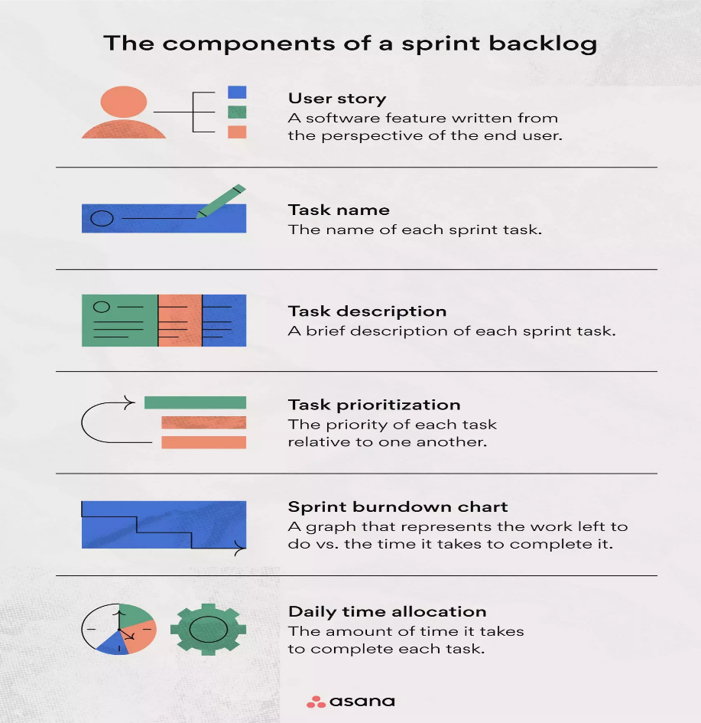

Scrum Master:

* A Scrum Master is a key role in the Scrum framework, which is a popular agile methodology for managing and delivering software development projects. The Scrum Master plays a crucial part in facilitating and supporting the effective application of Scrum practices within a team or organization.

Scrum Master responsibilities:

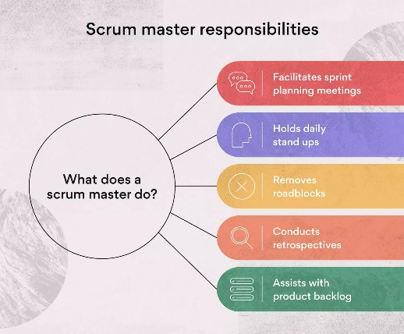

1. Facilitates sprint planning meetings:

* Sprint planning meetings help your Scrum team decide which items from the product backlog to prioritize for the next sprint.

1. Holds daily stand-up meetings:

* Daily stand-up meeting are essential part of scrum framework and responsibility of scrum master.

1. Removes roadblocks:

* Problem solving is a key quality of any good Scrum master. As the leader of your Agile team, you’ll want to move the project along as quickly as possible and make it easier for your team members to get their work done.

1. Assists with product backlog:

* The product backlog may involve features, tasks, bug fixes, technical debt, or knowledge acquisition.

1. Conducts Retrospectives:

* These meetings give Scrum team members a chance to identify areas for improvement during future sprints.

Increment:

* At the end of each Sprint, the team delivers a potentially shippable product Increment, which is a concrete step toward the product's vision.